FWT Builds Trails at WRNP

The Friends of Webster Trails had their first work day on Saturday April 22nd at the Whiting Road Nature Preserve. Work centered on building a new trail connecting the parking lot to the orange trail in the south of the preserve. There was also work on a reroute of the red trail to avoid a perpetually muddy section. More than a dozen workers participated in the clearing of brush and trees. Hot dogs were enjoyed in the parking lot following the successful day.

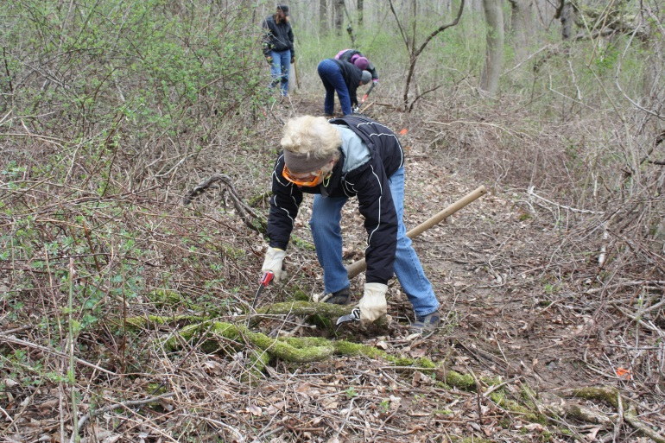

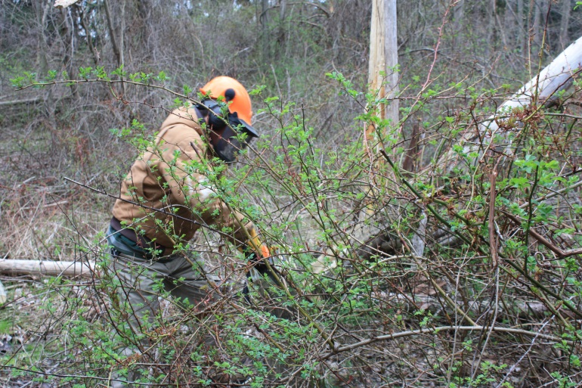
FWT workers clearing brush to make trail (Dennis Kuhn photos)

