Friends of Webster Trails (FWT) Work Day – May 20, 2017

Two dozen folks showed up for this monthly work day. The job was to improve the conditions on the new yellow trail in the Four Mile Creek Preserve. Lumber was carried long distances to the work sites and used to create walkways above chronically muddy areas. Elsewhere culverts were installed to allow for cross-trail drainage. While this was going on, a small group eliminated invasive garlic mustard from the blue trail where it was just starting to spread. The reward for the workers was hot dogs in the parking lot.

FWT has monthly work days such as the one described above. If you are interested in participating in our work days or joining FWT see our website at www.webstertrails.org.

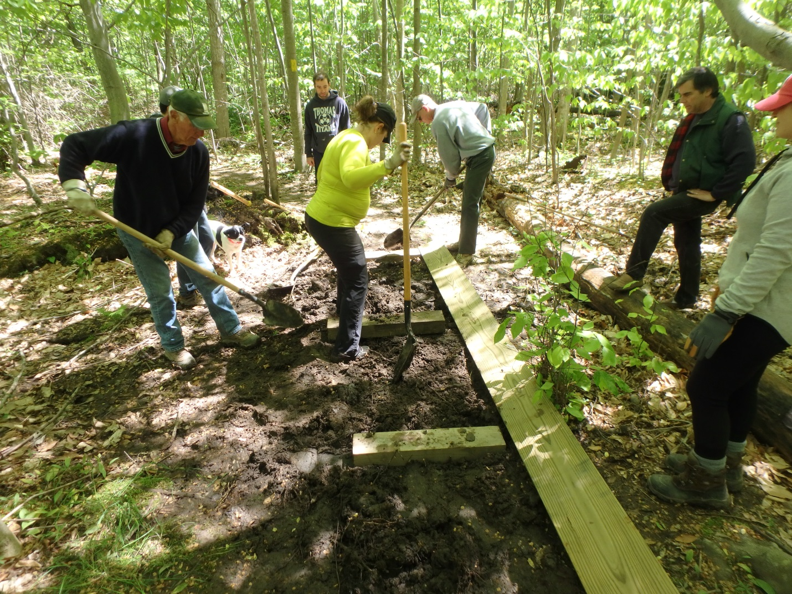
Photo submitted P5200361

